Arduino Module B.2

**Level 0:**

1. LED trailing Effects is when there are different types of LED which are connected into Arduino Board to create light and effect using different materials like resistors, jumper wires and etc.
2. The For Loop is used to repeat codes and execute them.
3. Common method for keeping track of data so that it can be accessed quickly.
4. Each time through the loops the condition is tested, if the condition is false the loop ends.
5. **The For Loop** is used to repeat codes and execute them. **While loops** will loop continuously, and infinitely, until the expression inside the parenthesis becomes false. **The do loop** works in the same manner as the while loop, with the exception that the condition is tested at the end of the loop, so the do loop will always run at least once.
6. Comparitor: is a device that compares two voltages or currents and outputs a digital signal indicating which is larger.

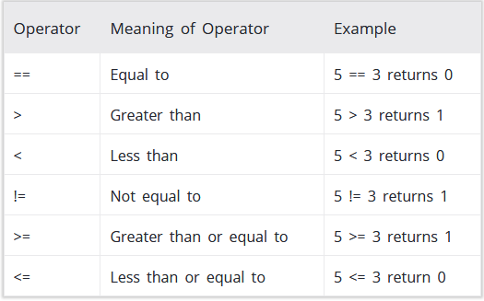

1. int BASE = 2; int NUM = 6; void setup(){for (int i = BASE; i <= BASE + NUM; i ++){pinMode(i, OUTPUT); //set port ‘i’ as an output port }}void loop(){for (int i = BASE; i <= BASE + NUM; i ++){digitalWrite(i, LOW); // Turn OFF the I/O board LEDdelay(200); }for (int i = BASE; i <= BASE + NUM; i ++){digitalWrite(i, HIGH); // Turn ON the I/O board LEDdelay(200); }}
2. Increment is increasing a value and Decrement is decreasing a value.
3. Add 1 to the value
4. int BASE = 2; int NUM = 6; void setup(){for (int i = BASE; i =+ BASE + NUM; i ++){pinMode(i, OUTPUT); //set port ‘i’ as an output port }}void loop(){for (int i = BASE; i =+ BASE + NUM; i ++){digitalWrite(i, LOW); // Turn OFF the I/O board LEDdelay(200); }for (int i = BASE; i =+ BASE + NUM; i ++){digitalWrite(i, HIGH); // Turn ON the I/O board LEDdelay(200); }}